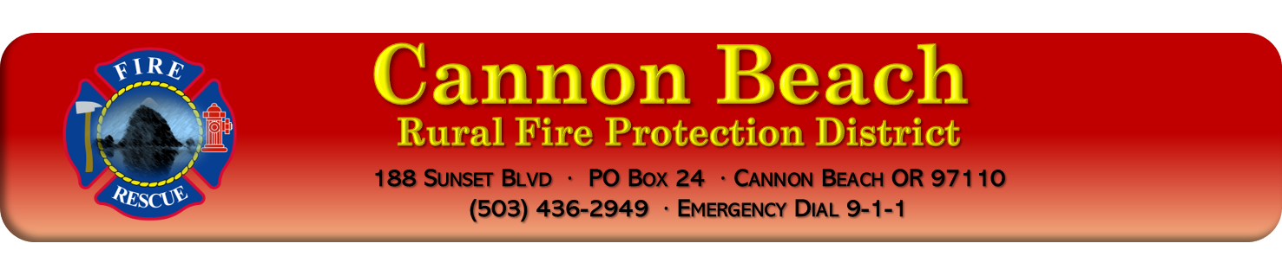

Board Meeting Minutes – May, 2022

General:
Date: | May
Time: | 18:02 hours (6:02 pm)
Location: | Cannon Beach Fire Station Board Room
Brought to Order Time: | 18:02 (6:02 pm)
Adjourned Time: | 19:26 (7:26 pm)

Attendees:
☐ Bob Cerelli (President) Zoom | ☐ Greg Bell (VP) Zoom | ☐ Rick Gardner (Treasurer)
☐ Jason Smith (DC) Zoom | ☐ Dave Herman (Member) | ☐ Marc Reckmann (Fire Chief)
☐ Karen Apple (minutes) | ☐ Bob Heymann | ☐ Bill Cotes (CPA) Zoom

Call to Order:
The Cannon Beach RFPD Board meeting for May , 2022, was called to order at 18:0 hours (6:00 pm) by Board President, Bob Cerelli.

Roll Call:
Board Members present were: Bob Cerelli, Bob Heymann, Greg Bell, and Rick Gardner.

Other attendees are: Marc Reckmann (Fire Chief, CBFD), Jason Smith (Division Chief, CBFD, Zoom), Karen Apple (Minutes) and Bill Cote (CPA).

Changes to Agenda:
None.

Public Comment:
None.

April 11, 2022 Board Meeting Minutes Approval:
April 11,2022 Minutes: XXX moved to approve the minutes. It was seconded by XXX. All were in favor, none opposed, motion carried.
April 11,2022 Executive Minutes: XXX moved to approve the minutes with the change. It was seconded by XXX. All were in favor, none opposed, motion carried.

Treasurer’s Report:
The Treasurer’s Report was read as written by Bill Cote. Highlights are summarized below.
  - Statement of Net Position (Balance Sheet). Read by Bill Cote as written and presented.
  - General fund: Read as written and presented.
  - Fire Chief fund: Read as written and presented.
  - Cash per Fund: Read as written and presented.

Bills:
Bills were reviewed by Board.

Correspondence:
Nothing to present.

Monthly review of board policies: XXX

Old Business:
- COWS. XXX
- Dispatch. XXX
- Strategic Planning. XXX

- Volunteer Housing. XXX
New Business:

- Station Lighting grant bid approval. XXX
- Resolution 22-01; Increase Rope/Surf Rescue Line Item. XXX
- Appointment of Budget Committee. XXX
- Lifeguard Inter-Government Agreement (IGA) and City. XXX
Reports:
- Chief’s Report:
  - Calls. XXX
  - State Parks Billing for Service. XXX
  - Strategic Plan. XXX
  - Grants. XXX
  - Hydrants. XXX
  - Tax. XXX
  - Apparatus: XXX
- Building: XXX
Radio: XXX
  - Chief Vacation: XXX
  - Apparatus 3225 XXX
  - Budget Committee. XXX
  - Questions? XXX

- Training Chiefs Report. XXX

Board of Directors Reports:
- Cerelli. Nothing to report.
- Gardner. Nothing to report.
- Herman. Nothing to report.
- Heymann. Nothing to report.
- Bell. Nothing to report
- Public. Nothing.

Good of the Order/Public Comment:

Adjourn:
- XXX motioned to adjourn which was seconded by XXX Adjourned at XXX hours (0.00 pm).
- Minutes submitted by Karen Apple
- Next Board Meeting scheduled for June , 2022.

_____________________________________________________________________ _____________________
Bob Cerelli, President CBRFPD Date:

